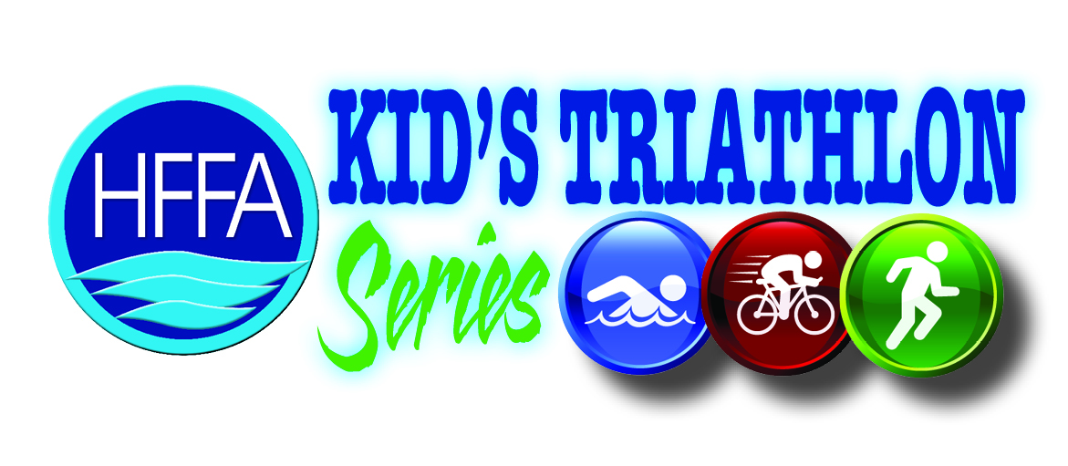

**YOUTH TRIATHLON CLINIC**

**Date: Friday, MAY 22, 2015**

**Location: HFFA- Huntersville Family Fitness & Aquatics**

|  |  |
| --- | --- |
| |  | | --- | | | 11725 Verhoeff Drive | Huntersville, NC 28078 | |

**Time: 5:30-7:30**

**Prepare for the HFFA kids triathlon #2**

**Ages 4 -14**

**COST: $15 HFFA Member $20 Non HFFA Member**

**FREE to TAC -Triathlon Academy of the Carolinas Shark members**

**We will go over the swim, bike, run and transitions**

**Please bring: Swimsuit, goggles, sneakers, and what you plan to race in. Bike and helmet suggested but are optional.**

**Email Kathy to reserve your spot…space is limited**

